Mechanical Overview

Year: 2025 Semester: Spring Team: 9

Project: Fairway Finder

Creation Date: September 10th Last Modified: September 12, 2024

Author: Saxon ZumBerge Email: szumberg@purdue.edu

Commercial Product Packaging
To select the most suitable enclosure for our Fairway Finder, Team 9 examined two commercial products and tried to replicate some of their packaging strategies. The two products that provided significant insights into our design were the Tempo Walk Autonomous Caddie by Club Car and the Axglo e5 Electric Golf Pushcart, which are detailed in Sections 1.1 and 1.2 below.

Product #1: Tempo Walk Autonomous Caddie by Club Car [1] & [2]

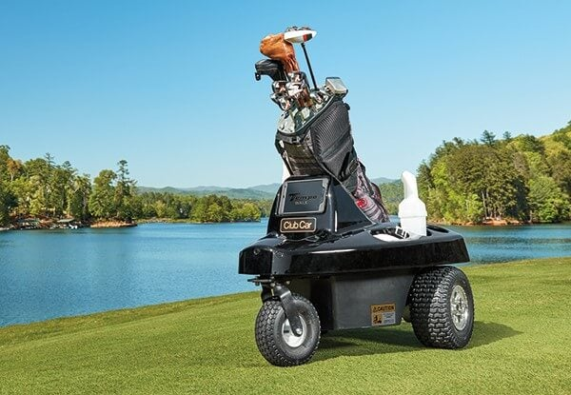

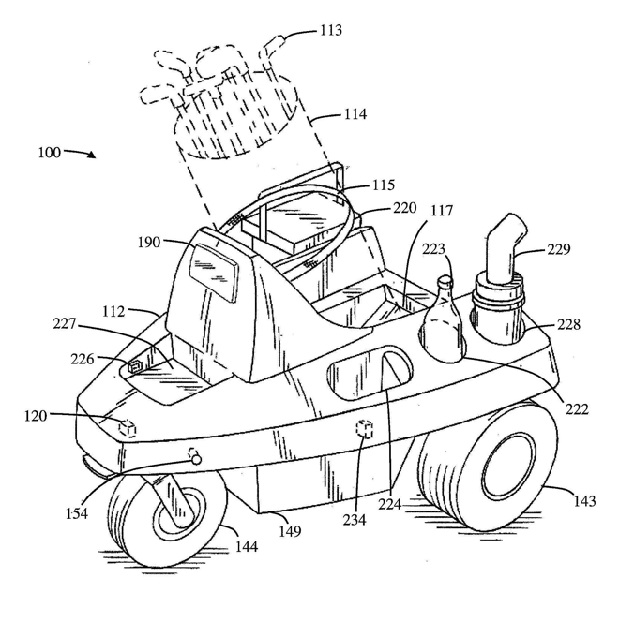

The Temp Walk Autonomous Caddie by Club Car is an autonomous golf caddie that will follow the user around a golf course.

Key Components

The Tempo Walk consists of several essential components, including:

A vehicle frame

A receiver device and remote transmitter

A processor unit

A motor and wheels

A variety of sensors

Autonomous Functionality

The caddie follows the user by tracking signals from a remote transmitter, which is carried by the golfer. This tracking system enables the caddie to autonomously navigate the course while staying close to the golfer.

Obstacle Detection & Navigation

Equipped with advanced sensors, the Tempo Walk can detect potential obstacles in its path and determine whether to stop or reroute. Its navigation system continuously analyzes the surroundings to prevent collisions and ensure safe movement on the course.

Signal Processing & Tracking

The receiver device on the caddie collects signals from the remote transmitter and transmits data to the processor unit. This system enables the caddie to accurately track and follow the golfer both on and off the course. Additionally, the sensors provide real-time environmental feedback, further enhancing its ability to navigate efficiently.

Positive Aspects

Professional and Durable: Club Car likely uses high-quality materials in their manufacturing. In combination with its unique build, it helps ensure a good working product for a long lifetime.
- Branding Appeal: The Club Car’s brand is closely associated with golf and golf carts so they have a very good reputation in the golfing community. Protective Elements: Given the size and complexity of the Tempo Walk, the packaging likely includes foam inserts, sturdy outer boxes, and reinforcements to protect the hardware components.

Negative Aspects
- Bulky and Heavy: Given its size and features, the packaging is likely large which makes transportation more challenging.
- Limited Customization: Since it’s a relatively mass-produced product, the packaging is standardized. This results in their not being specific customizations to accommodate specific users’ needs.

Adapting & Differentiating Packaging the Fairway Finder
One aspect of the Tempo Walk I plan to incorporate in our design is the ability to follow the user on the golf course. The ability to autonomously follow a user is a difficult task and is the one feature I want to completely invest in for my team's project. My team's Fairway Finder plans to be lighter and more transferable. The Tempo Walk has a strong sturdy design and has a lot of features that make it heavy. The average person cannot lift it into their car on their own. As a result, my team aims to provide a similar solution that is lighter and more transportable so that the average golfer can own and benefit from the Follow Me algorithm.

Product #2: Axglo e5 Electric Golf Push Cart [3] & [4]

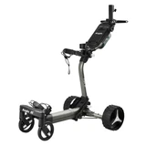

The Axglo e5 Electric Golf Push Cart is another autonomous electric golf caddie that is designed to enhance the walking golfer's experience by following the user.

Key Components

The Axglo e5 consists of several essential components, including:

Sturdy Frame and Adjustable Handle

Dual Brushless Hub Motors

A Processor Unit

Swiveling Front Wheels

Lithium-Ion Battery

A Variety of Sensors

LCD Display

Operational Modes

The Axglo e5 offers five distinct modes to suit various user preferences:

Follow Me Mode: By placing the remote control in your back pocket, the cart will automatically follow the user.

Remote Control Mode: Utilize the wireless remote to maneuver the cart around the golf course.

Power-Assisted Speed Control: Adjust the cart's speed by rotating the central knob, with nine speed settings available to match your walking pace.

Manual Push Mode: In situations where the battery is depleted or removed, the cart can be pushed manually without resistance.

Technological Features

Anti-Tipping Technology: The e5 is engineered to climb slopes up to 40 degrees on various terrains without tipping, ensuring stability and safety.

Obstacle Detection: The specific sensors used, and obstacle detection capabilities are not detailed. It should be noted that from the website users should remain attentive to the cart's path to prevent potential collisions.

Positive Aspects

Versatile Control Options: Multiple operational modes provide flexibility to suit different user preferences.

Compact and Lightweight Design: Weighing approximately 35 pounds with the battery and folding down to 25" x 16.5" x 14.5", the e5 is easy to transport and store.

User-Friendly Interface: The LCD display and remote control enhance the overall user experience.

Negative Aspects

Follow Mode Sensitivity: Some users have reported that the follow mode can be inconsistent, especially if the remote is obstructed or placed in a pocket.

Cost: MSRP is $2,599.99 CAD which makes this not obtainable for the average golfer.

Adapting & Differentiating Packaging the Fairway Finder
After reviewing the Axglo E5 one aspect I plan to incorporate in our design is the overall size and packaging of the product. It is much lighter and more transportable than the Tempo Walk, which makes it much easier for the average golfer. However, if we were to go to market with the fairway finder, I would encourage our team to make the price of our product a lot more affordable to the average golfer. Additionally, instead of the use of a remote control we plan to use a phone for those capabilities. Which eliminates the need for an additional product to be made which can hopefully be a point of reducing our “go to market price”.

2.0 Project Packaging Description

Overview of Packaging Design

The Fairway Finder packaging is designed to be light-weight, durable, and user-friendly. The foundation of our Fairway Finder is built upon a donated golf pushcart, repurposed to serve as the chassis of the autonomous golf caddie. This lightweight yet sturdy frame provides the necessary support for integrating motors, control systems, and ultra sonic sensors, allowing the device to operate efficiently at any golf course.

Motor Mounting & Wheel Integration Appendix [1] - “Wooden Chassis Mount”

To enable autonomous movement, we are fabricating motor mounts using 4x4 wooden blocks, which will be securely attached to the chassis. The motors will then be bolted to these custom-cut wooden blocks. The mounts will provide a stable base for the motors and ensure proper alignment with the rear wheels.

Component Mounting & Electronics Housing Appendix [1] &[3] - “Battery and PCB Holder”

To house the battery, PCB, and other electronic components, we will install a sturdy platform beneath the chassis. This platform will be made from an 11-inch by 20-inch wooden plank. This plank will serve as the primary electronics mounting surface.

The plank will be securely fastened to the lower frame of the pushcart, using hooks that were drilled into the plank. Which ensures that all electrical components remain stable during operation.

Axle Design & Wheel Attachment Appendix [1] - “Wheel Axle”

To effectively connect the motors to the existing pushcart back wheels, we are designing a custom axle system. This axle will serve as the linking mechanism between the wheels and the motors. The axle will be precision-cut to fit within the pre-existing wheel hubs, ensuring a secure fit. Keyed slots will be implemented to provide a firm grip between the axle and the motor shaft, preventing slippage during operation. Bearings or bushings may be added to reduce friction and improve rotational efficiency.

Project Packaging Specifications Appendix [2]
The packaging materials and components for the Fairway Finder have been carefully selected to balance durability, weight, and cost efficiency, as outlined in Appendix 2: Project Packaging Specifications. The total estimated weight of the system is roughly 1925 grams. This ensures that the caddie remains lightweight and easy to maneuver on and off the golf course. Some of the key components for the Fairway Finder include the wooden motor mounts and planks for structural support, sensor modules for navigation, and a lead-acid battery to power the system. The motors, securely mounted to custom wooden blocks is necessary for movement, while the axle and zinc-plated hooks facilitate stable wheel integration and electronics housing. Each component has been for functionality and ease of assembly using standard tooling such as drills and saws. The total cost of packaging materials is roughly $161.50, making the Fairway Finder an affordable autonomous solution.

3.0 Sources Cited
[1] “Golf cart anti-tipping system,” Google Patents, KR102477855B1, Sep. 3, 2021. [Online]. Available: https://patents.google.com/patent/KR102477855B1/en. [Accessed: 12-Feb-2025].
[2] Club Car, “Tempo Walk Autonomous Caddie,” Club Car, 2025. [Online]. Available: https://www.clubcar.com/en-us/golf-operations/fleet-golf/tempo-walk. [Accessed: 12-Feb-2025].
[3] Axglo, “Axglo e5 Electric Golf Push Cart,” Axglo, 2025. [Online]. Available: https://axglo.com/products/axglo-e5-electric-golf-push-cart-grey?variant=42639678144701. [Accessed: 12-Feb-2025].
[4] Golf Cart Guru, “Axglo e5 - Electric Golf Push Cart - Full Review and Demo,” YouTube, Jan. 2025. [Online]. Available: https://www.youtube.com/watch?v=dluc9RJJasA. [Accessed: 12-Feb-2025].
[5] Autodesk, “Tinkercad.” [Online]. Available: https://www.tinkercad.com. [Accessed: Feb. 15, 2025].

Appendix 1: CAD Model Illustrations

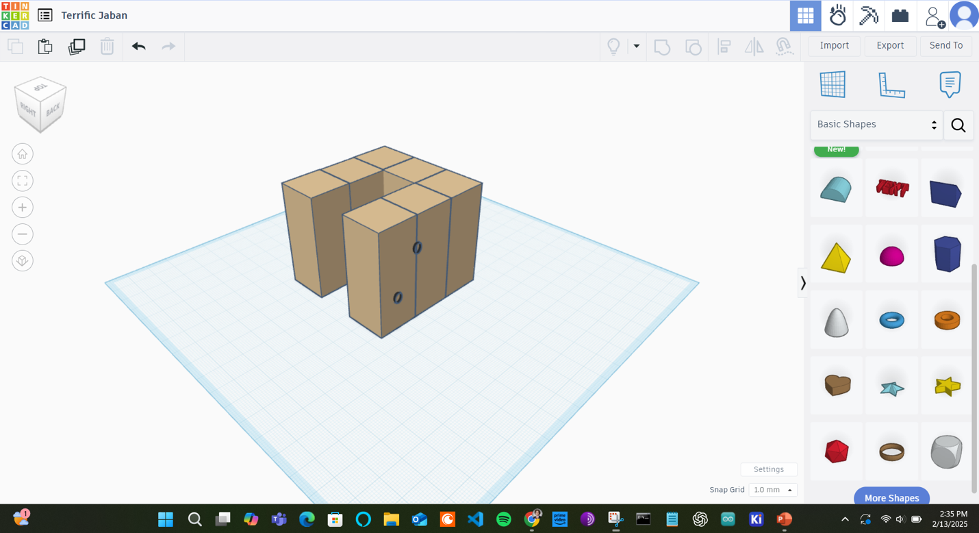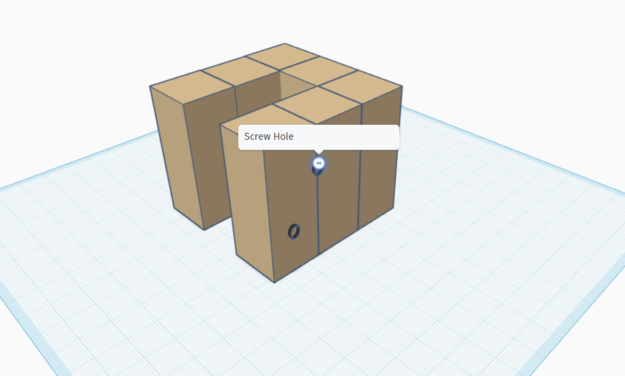

“Wooden Chassis Mount for Motor Attachment - Isometric View”

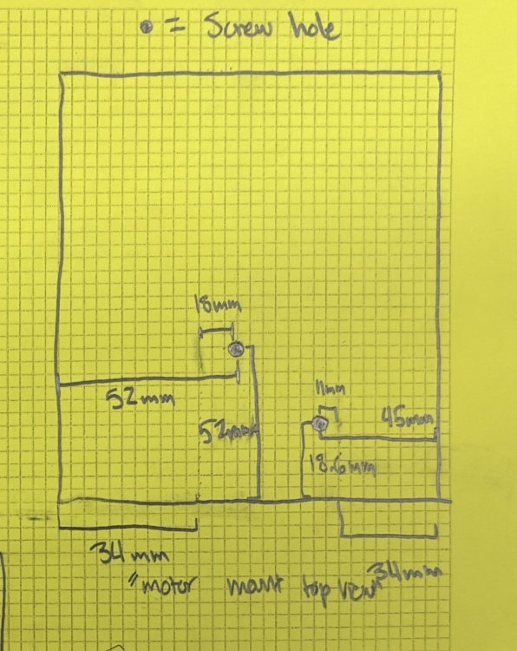

“Wooden Chassis Mount for Motor Attachment – Top View”

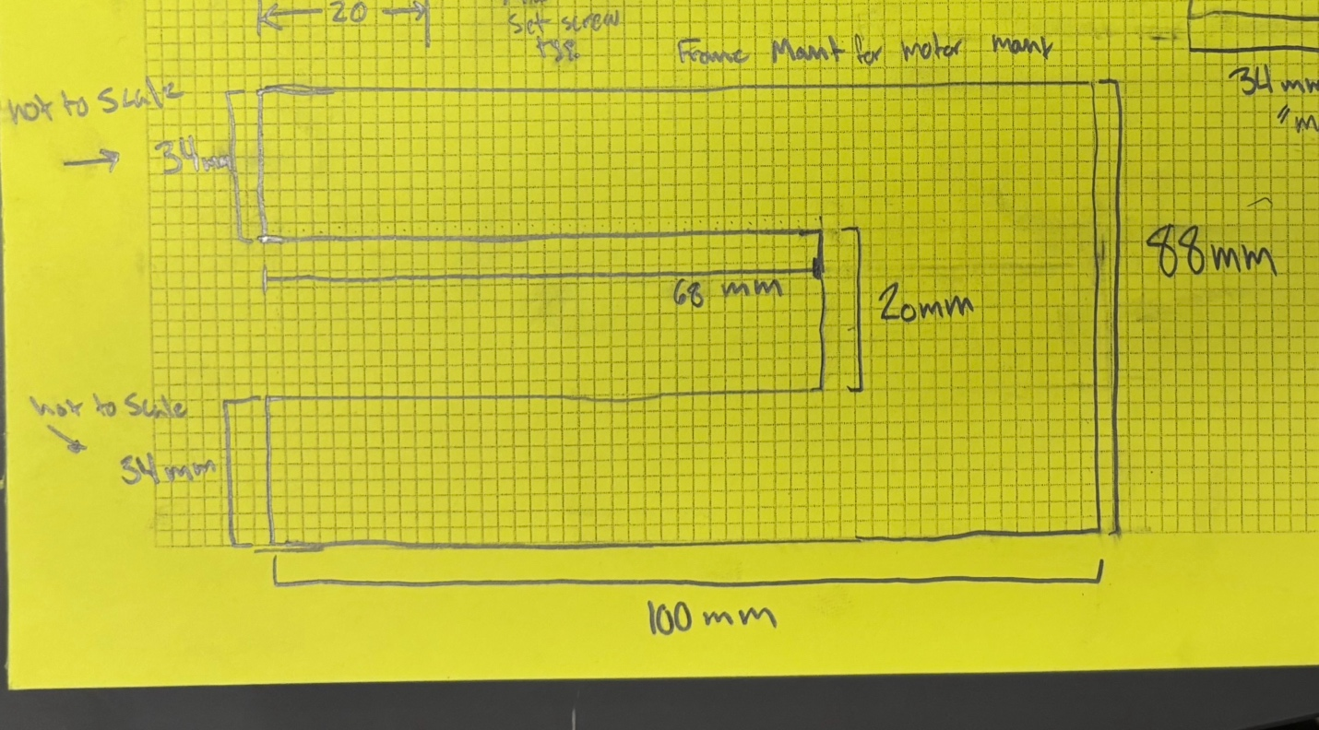“Wooden Chassis Mount for Motor Attachment - Side View”

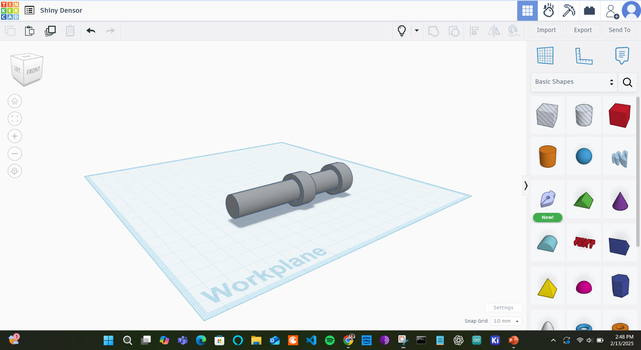“Wheel Axle -- Isometric”

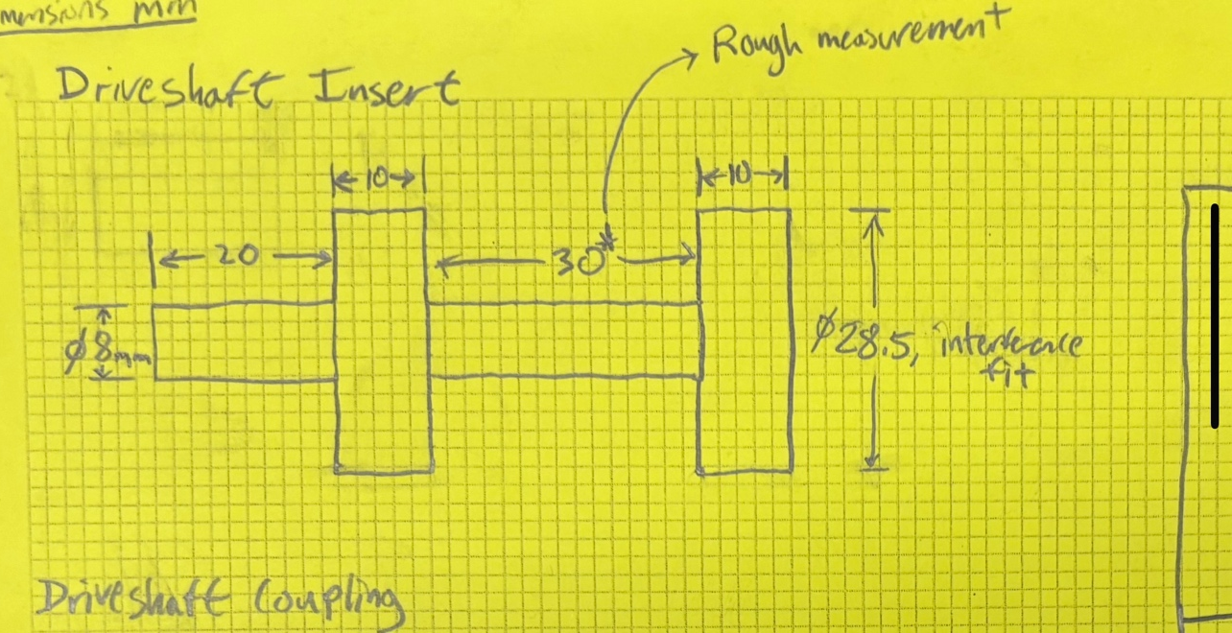

“Wheel Axle – Side/Front View”

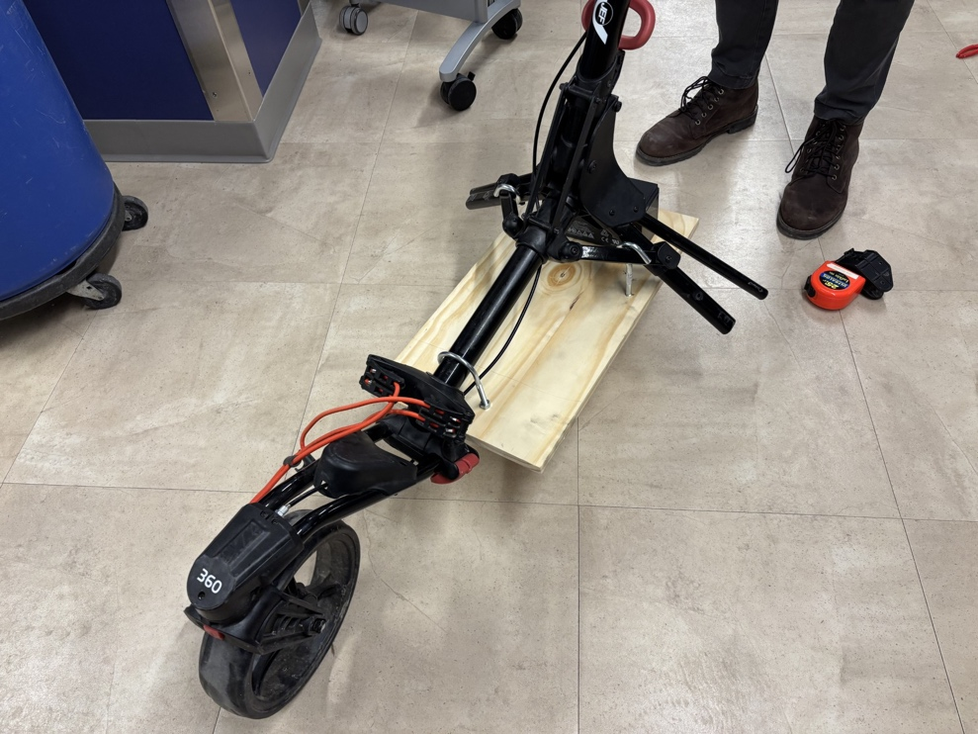

“Battery and PCB Holder – Isometric View”

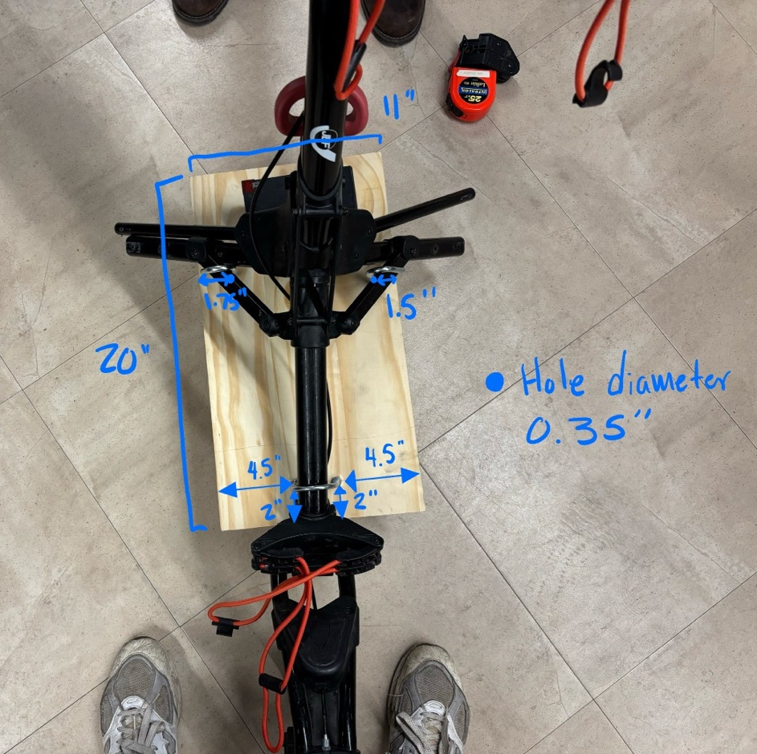

“Battery and PCB Holder – Top View”

Appendix 2: Project Packaging Specifications

Material | Tooling | Quantity | Estimated Weight | Estimated Unit Cost | Total Cost
Wooden Motor Mount | Table Saw, Drill, Adhesive | 2 | ~150 g | $10.00 | $10.00
PCB | PCB Manufacturing Tools, Soldering Iron | 1 | ~100 g | $20.00 | $20.00
Battery Lead-Acid | Soldering Iron | 1 | ~300 g | $25.00 | $25.00
Motors (DC) | Screwdriver, Soldering Iron | 2 | ~500 g (250g each) | $26.00 | $52.00
Wooden Plank (PCB & Battery Mount) | Table Saw, Drill | 1 | ~400 g | $8.00 | $8.00
Axle for Wheel | Lathe, Drill Press | 1 | ~350 g | $10.00 | $10.00
Zinc-Plated Hooks | Screwdriver, Drill | 3 | ~75 g (25g each) | $1.50 | $4.50
Sensor Modules | Soldering Iron, PCB Mounting Tools | 4 | ~50 g | $8.00 | $32.00
Total | N/A | N/A | ~1925 g | N/A | $161.50

Appendix 3: PCB Footprint Layout

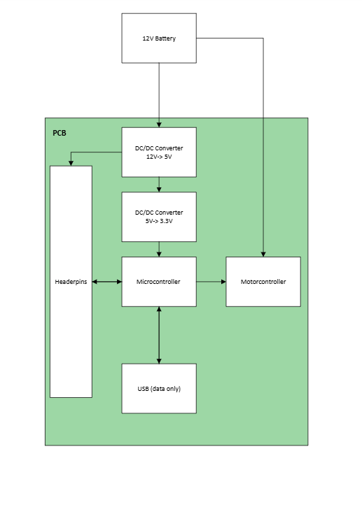

Headers pins will include all power and data pins for all external sensors.

Dimensions: 3 in. x 2 in.

